January 19, 2020
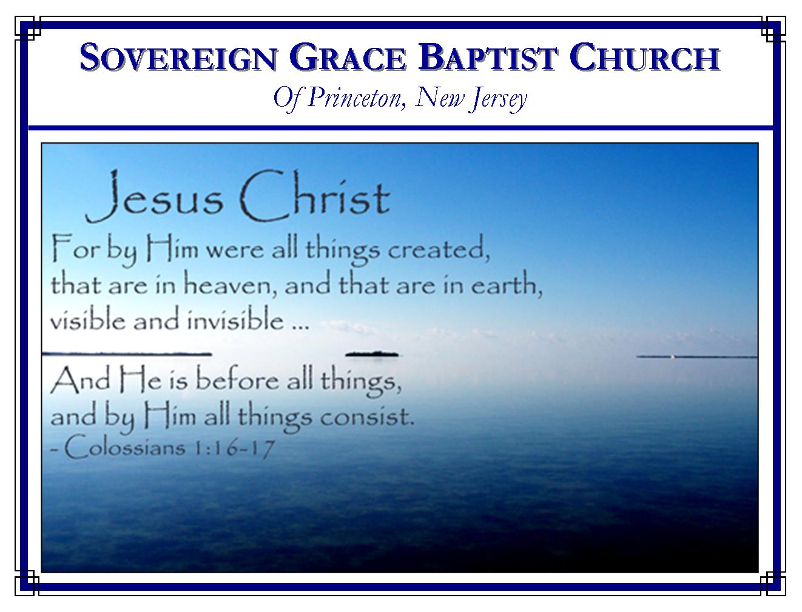
Weekly Schedule of Services
Sunday: | 10:15 AM | Bible Class
 | 11:00 AM | Morning Service
Thursday: | 7:30 PM | Mid-week Service
Services Broadcast Live @ www.FreeGraceMedia.com/live

Web Address
Be sure to bookmark our website for daily articles and audio messages:
www.FreeGraceMedia.com
Weekly Meeting Location  251 Green Lane  Ewing, NJ, 08638 | Mailing Address  7 Birch Street  Pennington, NJ 08534  Clay Curtis, pastor
Phone: 615-513-4464 | Email: clay@freegracemedia.com
If you would like to receive this bulletin sent weekly
to your email then send a note to the email address above.
Articles in this bulletin are by the pastor unless otherwise noted.

ANNOUNCEMENT
Wednesday, January 22, mid-week service rather than Thursday, January 23. I am scheduled to preach at Rescue Baptist Church Friday, Saturday and Sunday. Brothers Ben Moyer and Rob Keller will bring the messages next Sunday.
-----------------------------
Proverbs 14: 15: The simple believeth every word: but the prudent man looketh well to his going.
SCHEDULE OF SERVICES
10:15 am. Bible Class
11:00 a.m. Service: Hymns * Scripture Reading * Message* Hymn.
Scripture Today: Adam K Scripture Thurs: Rob K
Nursery Sun: Kayln P; Cheryl D Nursery Thurs: Kristyn K
Jan BDays: Donna P—16th; Vincent D-18th; John K--27th; Anniversaries: Scott and Christine K—2nd January Cleaning: R Keller Family

Sept Cleaning: The Kane Family

-----------------------------

“He Careth For You!”
1 Peter 5:7

For that child of God who is laboring under some present distress, there are no words sweeter than these — “He careth for you!” He cares for your soul. He cares so much that he gave his only begotten Son to redeem you from sin and supply you with every spiritual need. Surely, if Jesus Christ died to redeem your soul from death, you must know his great care. Not only is that so, the Lord God tenderly cares for the bodies and the concerns of the lives of his people. Do you believe that He cares? Then cast your care upon the Lord!
Are you troubled about your sin? Cast it upon the Lord. Are you troubled about some personal trial? Cast it upon the Lord. He was tempted in all points like as we are. He is touched with the feeling of our infirmities. He is able to help them that believe. Go, therefore, with your heavy burden to the throne of your merciful High Priest, cast your burden there and find grace and mercy to help in your time of need.
Pastor Don Fortner

-----------------------------

PRAY FOR MERCY
Here is a prayer that God never says no to… “Have mercy upon me.” Whenever someone asks for mercy, they are acknowledging their guilt before God, they are acknowledging His sovereign right to give or withhold it as He sees fit, and they are pleading their need of mercy. Everybody who truly pleads for mercy will have it. If you say, “I asked the Lord for mercy and He did not give it to me,” then you really never asked for mercy. You may have used the word “mercy” but that is not what you meant. Because if you meant what the Bible means by mercy, you would have it! The Lord did say, “Him that cometh to Me, I will in no wise cast out.” If you are not received in mercy by Him, it is because you never came to Him for mercy in the first place! Remember, “He delighteth in mercy.” Pastor Todd Nibert
-----------------------------

THE KINGDOM OF GOD IS NOT MEAT AND DRINK
Have we ever insisted on exercising our liberty in front of a weak brother by saying, “The kingdom of God is not meat and drink it is righteousness and peace and joy in the Holy Ghost.” If so, we should look at this passage again. The context says that if I know that the kingdom of God is not meat and drink then I should bear this weakness of my brother by not eating or drinking that which will offend him. Though I claim the kingdom of God is not meat and drink, yet by insisting on my liberty, I’m saying it is, I sin against my weak brother and I sin against Christ. But if I know that Christ is my Righteousness, Peace and Joy, that true worship is in spirit by the Holy Spirit, then I should want to limit my liberty in love to Christ and my weak brother.
Paul exemplified this. When men tried to force Titus to be circumcised, saying it was necessary for salvation, Paul refused. Why? By saying it was necessary they were saying Christ is not enough. Then on another occasion, Paul circumcised Timothy. Why? He was taking Timothy to preach in the Jew’s temple. Paul knew circumcision is nothing: if you are circumcised you are not better, if not you are not worse. But Paul also knew the Jews would think it something. They would never hear him preach the gospel of Christ if an uncircumcised, half-Gentile was sitting there in their midst. Therefore, he had Timothy circumcised. It showed that Paul truly believed that the kingdom of God is not in any temporal thing we do. Paul knew that we worship God in spirit, rejoicing in Christ Jesus and have no confidence in the flesh. And we are still commending Paul’s good unto this day.

-----------------------------

The Apostle Paul says, “Rejoice evermore. Pray without ceasing. In everything give thanks: for this is the will of God in Christ Jesus concerning you” (I Thess. 5:17-18). This is the will of God; that we rejoice always, pray continually, and give thanks. What we are, what we have, where we are, and all that happens in the life of a believer are all according to the will of God for us. Let us rejoice in prosperity or adversity and live in an attitude of thanksgiving and prayer, even when we have no particular request. Very ungrateful is the man who does not set so high a value on the love of God, the righteousness of Christ, and the hope of eternal life that he allows anything in this life to overshadow that wonderful gift of grace. How can I murmur and complain when I am a child of the King of Kings? Pastor Henry Mahan

-----------------------------

IN THAT DAY

Paul and Barnabas had a disagreement over Barnabas’ nephew, Mark. The disagreement became so sharp that these two brothers parted ways. It appears in scripture they may have reconciled. But this we know, when they each dropped this sinful flesh and came into God’s presence they were in complete harmony and agreement with one another.
Brethren, none of us want disagreements between our fellow brethren. We especially do not want it to develop to the point that we part company. But we have to face the fact that it does happen between believers. If it does it is sweet consolation to remember that when we drop this sinful flesh and are perfectly conformed to Christ’s image in glory none of the things that happened in our flesh will matter. In that day, each brother and sister will be in perfect agreement and perfect conformity as we bow side-by-side and give our gracious God all the praise and all the glory that Christ is our All. May God give us grace to remember that eternal day as we face the trials of this day.

