September 23, 2018
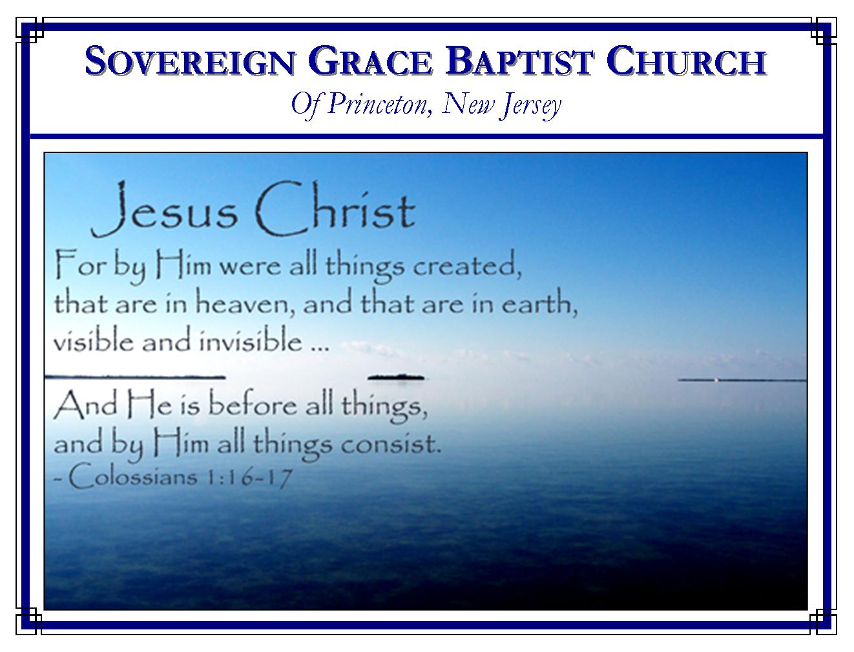
Weekly Schedule of Services
Sunday: | 10:15 AM | Bible Class
 | 11:00 AM | Morning Service
Thursday: | 7:30 PM | Mid-week Service
Services Broadcast Live @ www.FreeGraceMedia.com/live

Web Address
Be sure to bookmark our website for daily articles and audio messages:
www.FreeGraceMedia.com
Weekly Meeting Location  251 Green Lane  Ewing, NJ, 08638 | Mailing Address  7 Birch Street  Pennington, NJ 08534  Clay Curtis, pastor
Phone: 615-513-4464 | Email: clay@freegracemedia.com
If you would like to receive this bulletin sent weekly
to your email then send a note to the email address above.
Articles in this bulletin are by the pastor unless otherwise noted.
SCHEDULE OF SERVICES
10:15 am. Bible Class
11:00 a.m. Service: Hymns * Scripture Reading * Message* Hymn.
Scripture Today:Adam K Scripture Thurs: Ben M
Nursery Sun:Sarah K; Christine K Nursery Thurs: Kimberly T
BDays: Kelsie K—13th; Christine K--25th; Sarah K—27th; Anniv: Cyril & Lenore R 18th; Sept Cleaning: The Kane Family Grass This Week: Kevin T

Sept Cleaning: The Kane Family

-----------------------------

My new email is: Clay@FreeGraceMedia.com

Next, Friday, September 28, at 7pm at the church building we will resume the fourth Friday lessons for the young people.

-----------------------------

SUNDAY’S READING IN PROVERBS
Proverbs 12: 4: A virtuous woman is a crown to her husband: but she that maketh ashamed is as rottenness in his bones.

-----------------------------

ANCHOR OF THE SOUL
Which hope we have as an anchor of the soul, both sure and stedfast, and which entereth into that within the veil. Hebrews 6:19
On a recent trip to St. Croix, U.S. Virgin Islands to visit our friends, Daniel (Moose) and Sandy Parks, a coastguard ship was anchored off shore right in front of where my wife Teresa and I were staying. As we observed the ship several times during the day, the front of the ship would be pointing in different directions depending on how the wind was blowing. Yet the ship was never moved from its anchored position. Child of God, it is the same with our souls that are anchored to Christ. What great hope we have of never being moved from faith in our Savior. The Holy Spirit (the wind and breath of God) moves us in different directions by His sovereign power, purpose and providence to accomplish His will, but we are never moved from Christ, the Anchor of our souls. I find great comfort and assurance in the idea of my soul being anchored to Christ, “sure and stedfast.” Don’t you? Pastor David Eddmenson

-----------------------------

OUR STRENGTH IS THE LORD

Ephesians 6: 10: Finally, my brethren, be strong in the Lord, and in the power of his might.

Every elect child, born of God, is in a warfare. But our strength for this war is not of us but of God. Believers have no strength in us. None of the gospel exhortations given us by Christ are performed in our own strength.

Our strength is the Lord Jesus Christ, “be strong in the Lord, and in the power of his might.” The Lord told the apostle Paul, “My grace is sufficient for thee: for my strength is made perfect in weakness.” We are strong by the power of Christ resting upon us. When we are weak so as to look only to Christ then are we strong. (2 Cor 12: 9-10) “In all these things we are more than conquerors through him that loved us.” (Rom 8: 37)

A branch gets all its strength from the vine. Separate the branch from the vine and it withers away because it is cutoff from its life and strength. Likewise, the believer’s life and strength is from Christ who lives in us. Our Lord said, “Abide in me, and I in you. As the branch cannot bear fruit of itself, except it abide in the vine; no more can ye, except ye abide in me. I am the vine, ye are the branches: He that abideth in me, and I in him, the same bringeth forth much fruit: for without me ye can do nothing.” (Jn 15: 4-5)

So the Holy Spirit turns us to our strength, “Put on the whole armor of God.” (Eph 6: 11) Our armor for this fight is of God: God provides it, God gives it, God is the sum of it and God is the efficacy of it. “The weapons of our warfare are not carnal, but mighty through God to the pulling down of strong holds.” (2 Cor 10: 4)

-----------------------------

THE ENEMY

Ephesians 6: 11: Put on the whole armour of God, that ye may be able to stand against the wiles of the devil. 12: For we wrestle not against flesh and blood, but against principalities, against powers, against the rulers of the darkness of this world, against spiritual wickedness in high places.

In order to fight this war then we must know who our enemy is. Our enemy is the devil and a host of fallen, wicked powers. Indeed, we do wrestle against our own sinful flesh and we are opposed by wicked men. But our chief adversary is not man but the wiles of the devil. “Principalities and powers” are unseen spiritual demons which are fallen angels (2 Pet 2: 4). “The rulers of the darkness of this world” expresses their power and authority over all men who are in the darkness of spiritual death. “Spiritual wickedness in high places” means they are wicked spirits, wicked angels. Satan is called "the prince of the power of the air.“ (Eph. 2:2.) Believers wrestle against innumerable, invisible, wicked spirits which are all around us, which are under the power of the devil. This enemy is dangerous not only because of being invisible and strong, but because the devil is subtle, “Now the serpent was more subtil than any beast of the field which the LORD God had made. And he said unto the woman, Yea, hath God said, Ye shall not eat of every tree of the garden?” (Gen 3: 1) Someone said that the devil’s chains of bondage are made of satin so as to feel good to our sinful flesh. We need Christ our Strength and the whole armour of God to fight this enemy.

-----------------------------

OUR WEAPONS ARE SPIRITUAL

Ephesians 6: 13: Wherefore take unto you the whole armour of God, that ye may be able to withstand in the evil day, and having done all, to stand.

There was a picture of this armory under the old covenant. We read of “the tower of David, builded for an armory, whereon there hung a thousand bucklers, all shields of mighty men.” (SOS 4: 4) There were Solomon’s “three score valiant men, the valiant of Israel, who held swords, being expert in war: every man having his sword upon his thigh, because of fear in the night’ (SOS 3:7, 8). That earthly armory in earthly Jerusalem pictured our heavenly armory in heavenly Jerusalem made by our heavenly David, our heavenly Solomon, Christ Jesus. “The Lord hath opened His armory, and hath brought forth the weapons of His indignation.” (Jer 50: 25)

So he says “take the whole armor of God and “put on the whole armor of God.” The reason is “that you may be able to withstand in the evil day, and having done all to stand.” Each believer is to “with-stand” by “standing-with Christ our Captain”. The real battle sometimes comes after you have withstood the initial temptation. It comes in the form of pride or vain-glorying. We need these weapons before, during and after the temptation, so that after Christ has made us stand, we might continue to oppose and resist the evil. “The evil day” is not some great day in the end of time. It is trial, conflict and temptation we face every day.

JOSEPH HART wrote,

Gird thy loins up, Christian soldier;
Lo! thy Captain calls thee out;
Let the danger make thee bolder;
War in weakness, dare in doubt.
Buckle on thy heavenly armour;
Patch up no inglorious peace;
Let thy courage wax the warmer,
As thy foes and fears increase.

