July 21-23, 2017
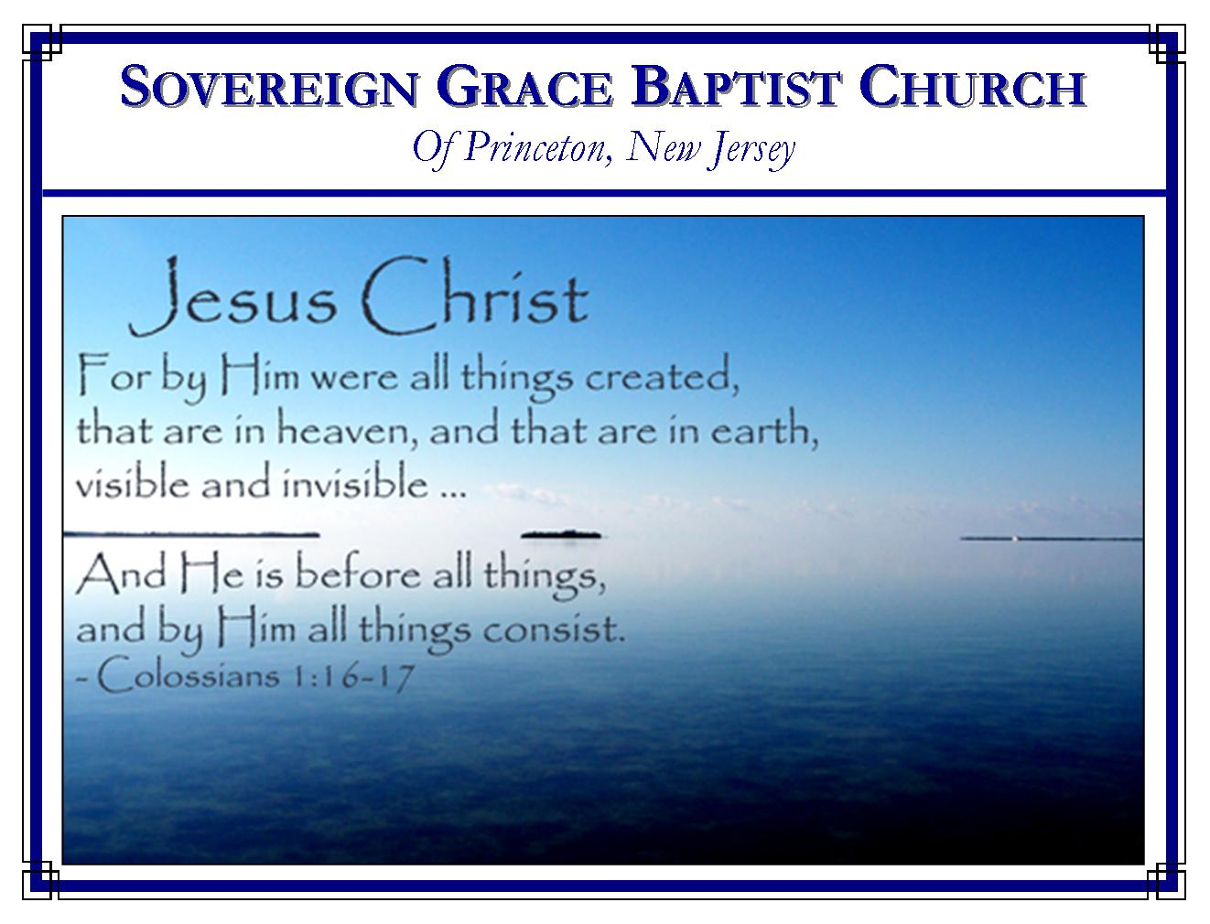
Weekly Schedule of Services
Sunday: | 10:15 AM | Bible Class
 | 11:00 AM | Morning Service
Thursday: | 7:30 PM | Mid-week Service
Services Broadcast Live @ www.FreeGraceMedia.com/live

Web Address
Be sure to bookmark our website for daily articles and audio messages:
www.FreeGraceMedia.com
Weekly Meeting Location  251 Green Lane  Ewing, NJ, 08638 | Mailing Address  7 Birch Street  Pennington, NJ 08534  Clay Curtis, pastor
Phone: 615-513-4464 | Email: clay@freegracemedia.com
If you would like to receive this bulletin sent weekly
to your email then send a note to the email address above.
Articles in this bulletin are by the pastor unless otherwise noted.
SCHEDULE OF SERVICES
10:15 am. Bible Class 11:00 a.m. Service: Opening Hymns * Scripture Reading * Message* Closing Hymn
Conference Nursery Fri: Cheryl D; Debra K Nursery Sat AM: Michelle L; Debbie D Nursery Sat PM: Christine K; Emma C; Nursery Sun: Kimberly T; Kristyn K BDays: Jailey T.—24th July Cleaning: Everyone

WELCOME TO OUR ANNUAL JULY MEETING!
This year’s meeting is extra special for our church family. This marks our 10th year together, as well as the 1st conference in our new building. We cannot thank our brethren in all the churches enough for your kindness in helping us. It is our chief desire that every word spoken from this pulpit, both in this meeting and in every service, will give God our Father and the Lord Jesus Christ all the glory in the salvation of his people. Since we closed on the building last September we have been busy preparing for this weekend. Just this week the last project was completed! We are happy to have our visiting brethren here to enjoy this special occasion with us and ask you to join us in thanking God for giving us a quiet place to worship him. The schedule for this weekend is as follows:

- Friday, July 21, 7:30 pm Don Fortner, pastor of Grace Baptist Church in Danville, KY and Marvin Stalnaker, pastor of Katy Baptist Church in Fairmont, WV.
- Saturday, July 22, 10:15 am Marvin Stalnaker and Don Bell, pastor of Lantana Grace Church, Crossville, TN
- Saturday, July 22, 6 pm Todd Nibert, pastor of Todd’s Road Grace Church, Lexington, KY and Don Bell
- Sunday, July 23, 10:15 am Todd Nibert and Don Fortner

We invite all to stay after each service for a meal. There is additional parking in the library parking lot directly behind the building. Turn left out of our parking lot, take the first street to the left then the first drive to the left into the library parking lot. There is a lighted sidewalk for your convenience. For those receiving this bulletin by email who are unable to attend, we welcome you to join us for each service via our live broadcast at www.FreeGraceMedia.com/live. Videos of each service will be available at www.YouTube.com/FreeGrace.

-----------------------------
WONDROUS GRACE!
By Pastor Don Fortner
“I will bring the blind by a way that they knew not; I will lead them in paths that they have not known: I will make darkness light before them, and crooked things straight. These things will I do unto them, and not forsake them.” (Isaiah 42:16)

When I review my life and trace the hand of the Lord my God in it, should I attempt to write a book about just the things I know, by the observation of experience, about his wondrous mercy, love, and grace by which he has led me in the path he appointed for me, what a huge volume might be written! I was blind, utterly blind to my own heart, blind to the glory of God shining forth in the face of Christ, blind to God’s mercy, love, and grace, blind to his holiness, blind to his justice, blind to his righteousness, and blind to his gospel. But he has made darkness light!
Before he saved me by his grace, God my Savior ordered my steps, though I knew him not, despised him, and rebelled against him at every turn. He hedged up my way; and none could deliver me from the grip of his grace. And since the day of my calling, he has proven himself faithful to this object of his relentless, unceasing mercy! He has brought me a way that I knew not, and led me in paths that I could never have known, had he not done it. And, blessed be his name, he is still graciously performing the same, making darkness light, and crooked things straight before me!
In the light of all that I read in his Word, and all that I know of his goodness and mercy, of his grace and love, of his faithfulness and truth, I have every reason to believe that as it has been, so it shall be. He has promised, “These things will I do unto them, and not forsake them.” He who had mercy upon me when I asked not for it, when I did not even know I needed it, will not now take his mercy from me. He still hedges up my way; and none can rip me from the grip of his grace! — “Surely goodness and mercy (Blessed hounds of heaven!) shall follow me all the days of my life; and I will dwell in the house of the Lord forever!

-----------------------------

SALVATION!
By Pastor Marvin Stalnaker
Salvation belongeth unto the LORD: thy blessing is upon Thy people. Selah (Psalms 3:8)
This verse reveals the substance and totality of the Gospel. It declares that salvation to needy sinners is altogether by the grace of God. It was God Almighty who chose His people in Christ before the foundation of the world that they should be holy and without blame before him in love. It was God Almighty who redeemed His people by the shedding of his own blood. And it is God Almighty who quickens all that He has everlastingly loved in regenerating grace. Yes, “salvation belongeth unto the Lord,” and “Thy blessing”…Salvation!...Christ Himself (Luke 2:30) “is upon (on) Thy people.”

-----------------------------
ABSOLUTE EXCHANGE
By Pastor Don Bell
“For by one man's disobedience many were made sinners, so by the obedience of one shall many be made righteous.” (Romans 5: 19)

It was by the sin of Adam that sin and death passed upon us, we not only had his sin imputed to us, but we also inherited his sinful nature. We then are sinners by birth and sinners by practice. “For there is not a just man upon earth, that doeth good and sinneth not” Eccl. 7:20.
But blessed be the name of the Lord the same way we became sinners we become righteous. We did nothing to become sinners; we do nothing to become righteous. There is an absolute exchange made, when our dear Savior went to the cross and died under the judgment and wrath of His Holy Father. He suffered not for himself but for those whom he represented. He was suffering the wrath of God because he was bearing his people’s sin upon his body on that tree. What was the absolute exchange? He became what I am, that I might become what He is; He took my sin, that I would have His righteousness; he took my disobedience, I get his obedience; he suffered my death, (my separation from God), that I would receive his life; He was made a curse, that I might be blessed; He was separated from God, that I might be brought nigh to God. (Gal. 3:13, 1 Pet. 3:18.)
Just as we also inherited Adams sinful nature, we also become partakers of Christ's nature. His holy nature is given to us in the new birth and it makes us love things we once hated and hate things we once loved. Our sinful natures loved sin, hated righteousness; now we love righteousness and hate sin. Once, listening to preaching and reading the bible would be the last things we would have done, now it is our delight.
“God hath sent forth the Spirit of his Son into your hearts, crying Abba, Father” (Gal. 4:6.) Thank God not only was Christ for us at the Cross, and accomplished our complete salvation, but, He is also in us “Christ in you, the hope of glory” Col. 1:27. By his Spirit in us, He continually works in us both to will and do of His good pleasure, and we are kept in the enjoyment of what He did for us by His sacrificial death on the cross. It is not only an absolute exchange; it is also an eternal exchange.
-----------------------------

CHRIST OUR RULE
By Todd Nibert
“And as many as walk according to this rule, peace be on them.” (Galatians 6:16)!

And what is this rule we walk by? The Law? No! It is this, “God forbid that I should glory save in the cross of our Lord Jesus Christ” (Galatians 6:14). Truly, this is the believer’s rule of life. This is our standard of measurement, Jesus Christ and Him crucified!
- This is our rule for understanding the Scriptures. All Scripture points to Him!
- This is the rule of our faith. He is the object of our faith!
- This is the rule of our assurance. Any assurance derived anywhere but simply glorying in the cross is a false assurance!
- This is the rule of our motives. Any motive other than His glory is a wrong motive!
- This is the rule of our doctrine. All of our doctrine finds Christ crucified as its sum and substance!
- This is our rule of motivation. His love to us “constraineth us!”
He is our rule in everything! He is that “one pearl of great price,” which a man sells all he has to possess. If Christ is not our rule of life, we have not yet known Him!
-----------------------------

ANNOUNCEMENT FOR OUR CONGREGATION
If it is the Lord’s will, next, Sunday, July 30, after our regularly scheduled services here, we will go to Ravi and Debbie Doodnath’s house where we will baptize Kimberly Thacker. We thank God for giving our sister a heart to believe on Christ and to confess him publicly before all.

