November 29, 2015
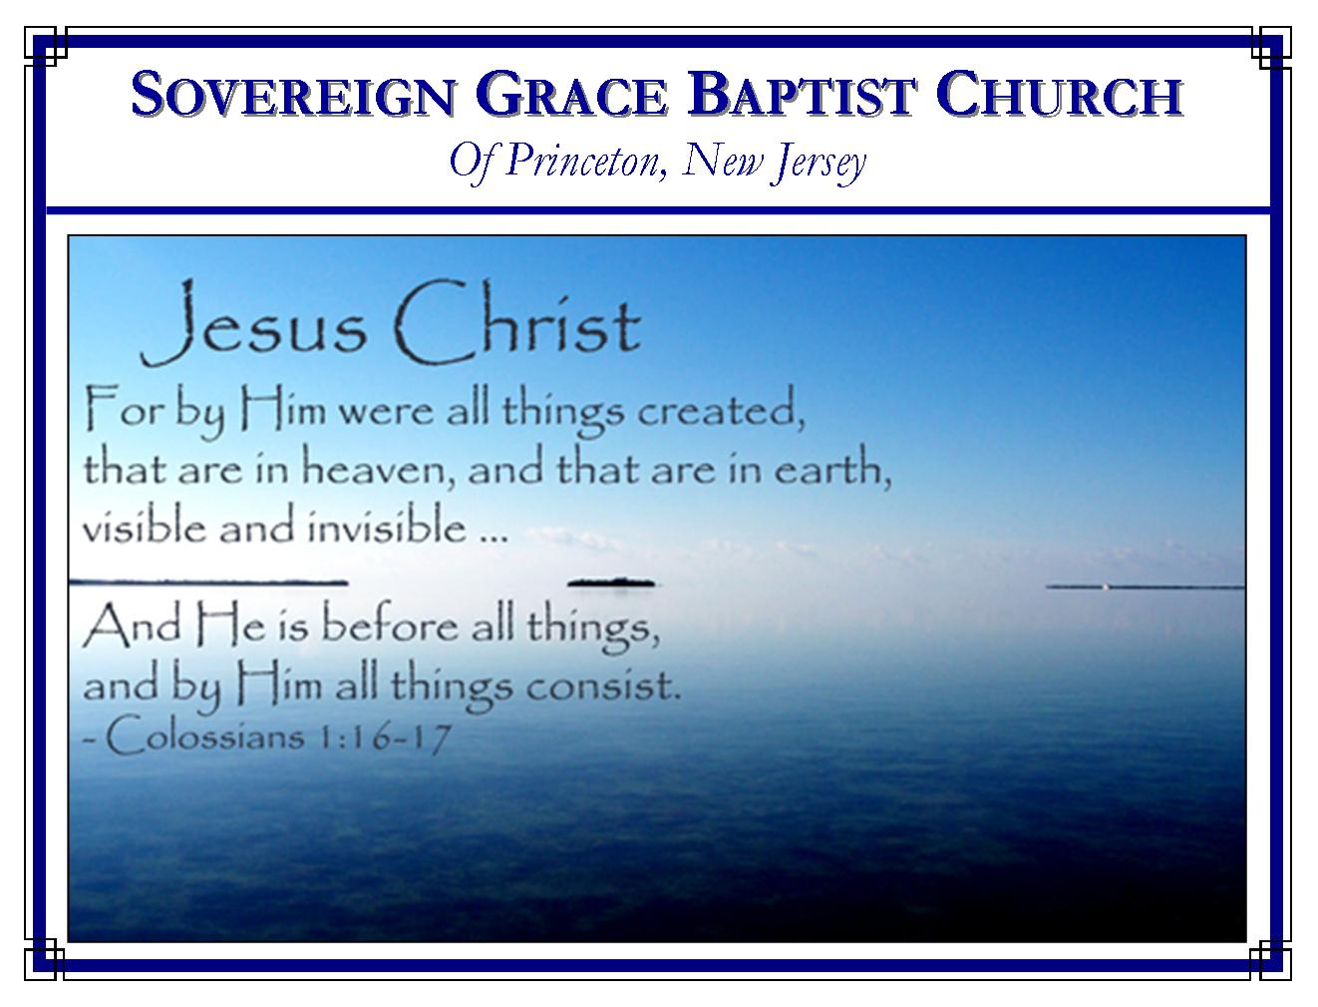
Weekly Schedule of Services
Sunday: | 10:15 AM | Bible Class
 | 11:00 AM | Morning Service
Thursday: | 7:30 PM | Mid-week Service
Services Broadcast Live @ www.FreeGraceMedia.com/live

Web Address
Be sure to bookmark our website for daily articles and audio messages:
www.FreeGraceMedia.com
Weekly Meeting Location  Rocky Hill Firehouse, 2nd floor  150 Washington Street  Rocky Hill, NJ 08553 | Mailing Address  7 Birch Street  Pennington, NJ 08534  Clay Curtis, pastor

SCHEDULE OF SERVICES
10:15 a.m. Bible Class
11:00 a.m. Service
Opening Hymns * Scripture Reading * Message* Closing Hymn
Nursery Today: Melinda C. Nursery Thurs: Debbie D. BDays: Kevin D—8th; Rachael D—9th; Scott K—9th; Peter D—20th; Abigail L—23rd; William K—23rd; Robert K. 29th; Wedding Anniversaries: Ravi and Urmilla Inderjeet—17th

GRACE, SALVATION, FAITH: THE GIFT OF GOD

Ephesians 2: 8: For by grace are ye saved through faith; and that not of yourselves: it is the gift of God: 9: Not of works, lest any man should boast.

Grace is a gift—grace is given from God to whomsoever God chooses, not based on anything in the sinner. (Rom 9: 11, 15, 16) Grace is not of works or it ceases to be grace. (Ro 11:6) God says of grace “and that not of yourselves: it is the gift of God: not of works, lest any man should boast.”
Salvation is a gift—“Salvation is of the Lord.” (Jon 2: 9) No aspect of salvation is performed by the sinner but by the triune God in Christ Jesus. Christ himself is Salvation. (Lu 2: 28-30) God says of salvation “and that not of yourselves: it is the gift of God: not of works, lest any man should boast.”
Faith is a gift—we have no reason to boast in our faith. If a heart surgeon put a new heart inside of you and you awoke to find yourself breathing, would you say, “Well at least I took a breath!” Breathing is the natural effect of life, without us making a concentrated effort to do it. Faith is the breath of the Spirit, the effect of Christ the Life dwelling in us. (Gal 2: 20) When God gives a new heart we find ourselves believing on Christ and cannot do otherwise. God says of faith “and that not of yourselves: it is the gift of God: not of works, lest any man should boast.”

-----------------------------
Whatever would lessen Christ's sufferings, would lessen Christ's love to us. Jesus Christ underwent those pains which were equivalent to the pains of hell. He felt the displeasure of the Almighty; He was in a soul-agony when He was deserted. All which aggravates Christ's passion all the more—and declares His compassion to us.—Thomas Watson
-----------------------------
Psalm 36:8: They shall be abundantly satisfied with the fatness of thy house; and thou shalt make them drink of the river of thy pleasures. 9: For with thee is the fountain of life: in thy light shall we see light.
-----------------------------
GLORY IN THE LORD
1 Cor 1: 29: That no flesh should glory in his presence. 30 But of him are ye in Christ Jesus, who of God is made unto us wisdom, and righteousness, and sanctification, and redemption: 31 That, according as it is written, He that glorieth, let him glory in the Lord.
If a sinner contributes to God’s works even slightly then he will boast. But God says “That no flesh should glory in his presence.” (1 Cor 1: 29) When the scripture declares “Salvation is of the Lord” it means each person in the Godhead does the saving.
- Here is God the Father in divine election—“Of God are ye in Christ Jesus.”
- Here is God the Holy Spirit in regeneration giving us faith—“who of God is made unto us.”
- Here is God the Son—“Wisdom, Righteousness, Sanctification and Redemption.”
The triune God does everything in salvation so that helpless sinners contribute nothing “that, according as it is written, He that glorieth, let him glory in the Lord.” (1 Cor 1: 29-31)

-----------------------------

LIKE A CHILD
“Verily I say unto you, Except ye be converted, and become as little children, ye shall not enter the kingdom of heaven” (Matt. 18:3).

One of the wonderful and amazing things about little children is their implicit trust and confidence in their parents. They only need a simple statement or promise from Mom or Dad as the foundation of that trust and confidence. Lengthy explanations are not required nor asked for. Simply make them a promise and sincere belief and trust springs up in their hearts. How is this manifest? They follow Mom and Dad around, living on that promise, continually reminding them of it, and awaiting its fulfillment!
Is not that the way the children of God live before their heavenly Father? “These all died in faith, not having received the promises, but having seen them afar off, and were persuaded of them, and embraced them, and confessed that they were strangers and pilgrims on the earth” (Hebrews 11:13). Pastor Maurice Montgomery

-----------------------------
“MY BELOVED IS MINE AND I AM HIS”
Every soul has a beloved—something or someone in which to glory, rejoice and enjoy. With some it is THE WORLD (its’ vanity, materialism, and honors). With others it is THE FLESH. They live to entertain the flesh, and to pamper the flesh. With others it is THE FAMILY. Close and distant relatives, family trees, family reunions make up their past, present and future. With others it is RELIGION and works of righteousness. Their religion is not a PERSON; it is a CAUSE to which they are devoted in hope of a suitable reward. And with some it is SELF, pure and simple; what can we do for me?
To a believer, IT IS CHRIST! He worships, loves, rejoices and glories in the Lord Jesus above all things. Christ is my Beloved and “my beloved is mine and I am His.” Christ (His fellowship, His love, and His approval) is preferred above persons, possessions, pleasures, or pursuits. Could ONE so illustrious and supreme deserve any less? “Whom have I in heaven but Thee? And there is none upon earth that I desire beside thee!” (Psalm 73: 25). Pastor Henry Mahan

