November 30, 2014
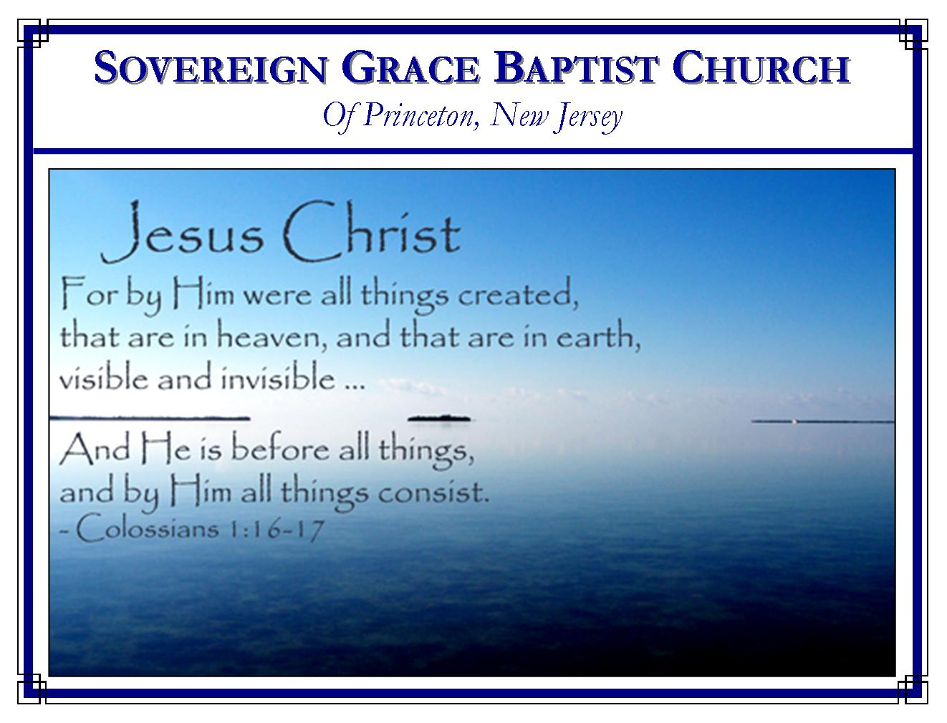
Weekly Schedule of Services
Sunday: | 10:15 AM | Bible Class
 | 11:00 AM | Morning Service
Thursday: | 7:30 PM | Mid-week Service
Services Broadcast Live @ www.FreeGraceMedia.com/live

Web Address
Be sure to bookmark our website for daily articles and audio messages:
www.FreeGraceMedia.com
Weekly Meeting Location  Rocky Hill Firehouse, 2nd floor  150 Washington Street  Rocky Hill, NJ 08553 | Mailing Address  7 Birch Street  Pennington, NJ 08534  Clay Curtis, pastor
Phone: 615-513-4464 | Email: clay@freegracemedia.com
If you would like to receive this bulletin sent weekly to your email then send a note to the email address above. Articles in this bulletin are by the pastor unless otherwise noted.

-----------------------------
SCHEDULE OF SERVICES
10:15 a.m. Bible Class
11:00 a.m. Service
Opening Hymns
Scripture Reading
Message
Closing Hymn
Nursery Today: Michelle L Nursery Thurs: Carol D B’Days: Kevin D-8th; Rachael D-9th; Scott K--9th; Peter Doodnath—20th; Abigail L--23rd; William K--23rd; Robert K. 29th; Anniversary: Ravi and Urmilla I—17th
We have a nursery equipped with a digital flat screen television broadcasting all services live, for children 4 and under.
-----------------------------
Proverbs 22: 6: Train up a child in the way he should go: and when he is old, he will not depart from it.
If God has made us faithful fathers and mothers then we spend a great deal of our time training our children. But in what do we spend the most time training them? We certainly train them how to be mannerly, give them the basics of respect and of caring for themselves. Also, we spend much time training them in their school work. Unknowingly, as they watch us, we train them to sin and we are masters at teaching them this. But how much training do we give them in “the Way” they should go, Christ Jesus? It is amazing how much we will spend for higher education so that our children can be trained up in the world’s way but then allow them to go without any training in the scriptures. Men and women will spend hours researching a college but then allow their child to attend any church service without any research to find out if the doctrine they preach is according to the scriptures.
If God has made us faithful fathers and mothers then let us give ourselves to train up our children in Christ the Way. Only God can bless it; only God can create them anew; only God can bring them to faith in Christ. But knowing God is able should make us eager to train them up in the gospel! If God reveals Christ in their hearts this will be the most important training they ever receive. By God’s keeping grace, when they are old, they will not depart from it. Think of this. Everything we train them in will be left behind when they leave this world. But if God blesses the gospel to their hearts, when they depart this life, the training we gave them will still be with them. God give us grace to train up our children in the Way everlasting.
-----------------------------
SERVING OUR GENERATION
“David served his own generation by the will of God”-Acts 13:36
David served his own generation very well and he has been serving all generations ever since. How many of us has he ministered unto by the words he pinned down thousands of years ago. His writings have given us light as we walk through the valley of the shadow of death. In our sorrows he has encouraged us to hope in God who is the help of our countenance. King David is dead but he yet is speaking and serving us till this very day.
…when it comes to serving your own generation, you may be very useful, if it be God’s will. We can’t write a book but we can pray. Prayer to God has accomplished more than all the books of man combined. “The effectual fervent prayer of a righteous man availeth much.” The Lord may never inspire you to write a song but if he gives you a heart to come to the throne of grace and plead for your generation that may well accomplish much.
Don’t all of us have neighbors who are lost? Don’t we have loved ones who are without Christ and hope? Who knows if God may use us as an instrument to win them. John Bunyan overheard two ladies speaking of the love of Christ to their souls and it was God’s will to use their words in the conversion of Mr. Bunyan. And look how that man has served so many generations. Oh, if God wills it, one word spoken from your feeble lips may well bring down the kingdom of Satan in a poor sinner’s heart.
You are not called to travel and preach the gospel, but there are nursing homes just a few miles away with people who need the Holy Scriptures read to them. I know a lady who took time to go to the nursing home daily for a year or more to read the word of God to a person dying of cancer. One man told me he had gone to visit a man in the hospital who had only days to live. He read the forth chapter of John to the dying man and hearing that the Savior had saved the sinful Samaritan woman, the man began then and there to seek the Lord himself and confessed that very day that the Lord Jesus had saved him too. You and I may feel like we can do very little. But little is much if God is in it. Let us be like that dear woman in the gospels who did what she could. Let us do what we can to serve our own generation, and eternity may witness that it was more then we could ever imagined – simply because it was God’s will. Oh, is not our God’s will sovereign? Don’t the Bible say that none can resist his will? By his grace then let us serve our generation and leave it all in God’s will to do nothing with it or little or if he is pleased do great things. God’s will is all that matters. Nothing else is worth talking about.
Let us serve our families by being patient when everything seems so dysfunctional. Let us be kind and tender hearted and forgive one another daily. Let us be faithful to the public worship of our God and Savior. This pleasure seeking generation has little regard for public worship. What a service it may be to them to see and hear of the saints forsaking not the assembling of themselves together. Above all else, tell them of Jesus the mighty to save. Preach to them that through this man there is forgiveness of all sins and all that believe in him are justified from all things. God give us grace to serve our own generation. Bruce Crabtree, Pastor of Sovereign Grace Church, New Castle, IN

-----------------------------
How Lost Were We?
How utterly abominable and wicked we must be, that nothing less than God coming down and taking unto Himself human flesh, and "being made in the likeness of sinful flesh", so that He would have a body in which He could suffer death on the cross.
How awful sin must be, and how horribly sinful we must be, that Christ Jesus our Lord must be the one “Who his own self bare our sins in His own body on the tree” (1 Pet. 2:24), and “pour out his soul an offering for sin”. Sin is indeed exceeding sinful that it would take such a sacrifice.
How utterly lost, helpless, and without any ability to better ourselves before an infinitely holy and righteous God we must be, that Christ, God's dear Son would take our place before His Holy Father on the cursed tree and there bear what I could not bear, which is the infinite righteous wrath and justice of God against us and our sin.
By his suffering in our stead, He consumed the wrath of God which was against us, and he satisfied God's infinitely righteous justice for us. Yet after Christ, having done all this in our room and stead, we are totally unable to see these things, or to know these blessed truths, or even care about them unless we are born again! Our carnal minds were enmity against God, we were enemies in our minds by wicked works, and so how are our minds changed from enmity and our wills brought into subjection to God?
It will take omnipotent power to make us willing to be saved; we must be drawn to God because we are unwilling to come. We must be given new hearts, new wills, new minds, new desires, new loves, and new natures if we are to enter the kingdom of God. None of these things can we do for ourselves. But blessed be God, He loved us and gave His Son for us, and with him he freely gives all things, he sent the spirit of his Son into our hearts and we cry Abba Father. Our gracious God, in making his Son’s death effectual to us, makes us new creatures In Christ. He brings into existence a new man. It is this new man that is able to see, to believe, and to walk and commune with God in Christ. Donnie Bell, Pastor of Lantana Grace Church, Crossville, TN

